**Project Design Phase-II**

**Technology Stack (Architecture & Stack)**

|  |  |
| --- | --- |
| Date | 17 NOVEMBER 2023 |
| Team ID | PNT2022TMIDxxxxxx |
| Project Name | Project - xxx |
| Maximum Marks | 4 Marks |

**Technical Architecture:**

The Deliverable shall include the architectural diagram as below and the information as per the table1 & table 2 **Example: Order processing during pandemics for offline mode**

**Reference: https://developer.ibm.com/patterns/ai-powered-backend-system-for-order-processing-during-pandemics/**

Guidelines: 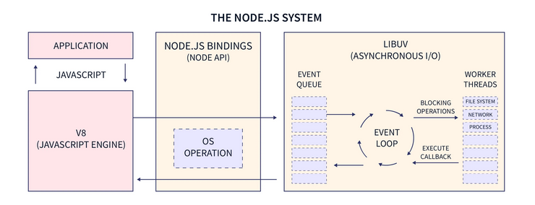

**Table-1 : Components & Technologies:**

|  |  |  |  |
| --- | --- | --- | --- |
| **S.No** | **Component** | **Description** | **Technology** |
| 1. | User Interface | User can access our frontend and upload an image of the scan and get the results | HTML(EJS), Bootstrap, JavaScript, ChartJS |
| 2. | NodeJS | User’s webpages (i.e., templates) are handled and routed by using expressJS and nodeJS | JavaScript, expressJS, nodeJS |
| 3. | Flask | Model predictions are done on flaskJS server | Flask, TensorflowJS |
| 4. | chartJS API | Charts to render the results | chartJS |
| 5. | CNN | Image pattern detection among trained scans using keras layers and SMOTE principle to increase efficiency | Pattern Recognition model |

**Table-2: Application Characteristics:**

|  |  |  |  |
| --- | --- | --- | --- |
| **S.No** | **Characteristics** | **Description** | **Technology** |
| 1. | Bootstrap | Bootstrap is a frontend styling library which maximises the efficiency and minimises the CSS coding | Bootstrap v5.0 |
| 2. | Security Implementations | Uses https protocol for more secure information transfer | https |
| 3. | Scalable Architecture | This can be scaled as an external independent API as it does not depend on Database which makes it easily acessible | Flask and nodeJS server |

|  |  |  |  |
| --- | --- | --- | --- |
| **S.No** | **Characteristics** | **Description** | **Technology** |
| 4. | EJS | EJS is a html templating engine which increases the efficiency and reduces the cluster and repetition of html blocks and uses Javascript logic to template the HTML | EJS |

**References:**

[**https://getbootstrap.com/docs/5.1/getting-started/introduction/**](https://getbootstrap.com/docs/5.1/getting-started/introduction/)

[**https://ejs.co/#docs**](https://ejs.co/#docs)

[**https://expressjs.com/en/5x/api.html**](https://expressjs.com/en/5x/api.html)

[**https://flask.palletsprojects.com/en/3.0.x/**](https://flask.palletsprojects.com/en/3.0.x/)

**https://www.tensorflow.org/api_docs**